# How to make a EDDiscovery release

1. Check that EDDiscovery has a new releasenumber in Assemblyinfo.cs.   
   [assembly: AssemblyVersion("8.0.6.0")]

[assembly: AssemblyFileVersion("8.0.6.0")]

1. Compile EDDiscovery in release mode   
     
   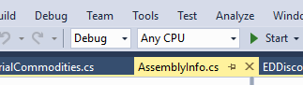
2. Go to EDDiscovery\Installer directory. Open EDDiscovery.aip with Advanced Installer
3. In Product details change version number to the same as EDDiscovery has (in point 1)  
   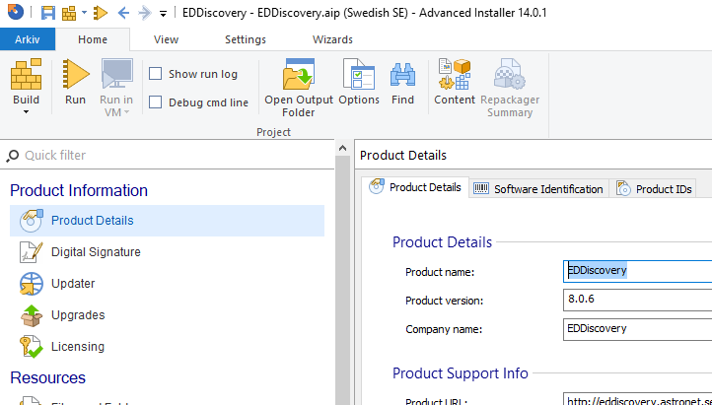
4. Click on Files and folders (you get a checkbox) answer **Generate New**.

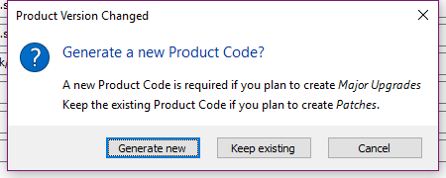

1. In files and folders check that EDDiscovery has correct version (if not you might have built it in debug or failed to compile)  
   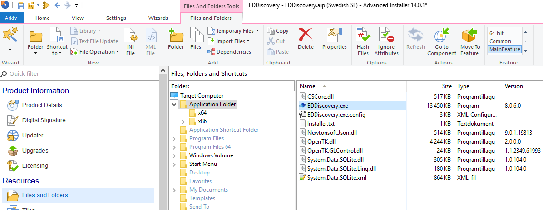
2. Go to Home tab and press build button

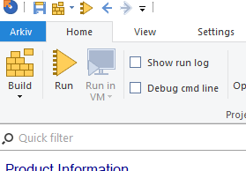

1. Press button open output folder  
   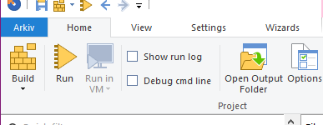
2. Go to en sub-directory and you find the english EDDiscovery.exe installer.
3. Save instlaller and commit and push EDDiscory project to github.

Make release on Github

1. Go to <https://github.com/EDDiscovery/EDDiscovery/releases>
2. Press **Draft new releases**
3. Fill in a tag version. Ex: Release_8.0.6. Remember to select correct branch master or 8.1….  
   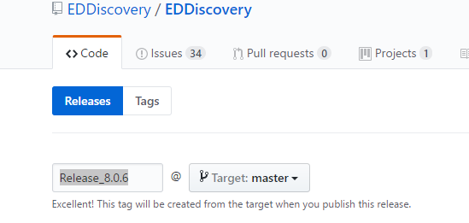
4. Name it for example Release 8.0.6
5. Enter a description of the release.

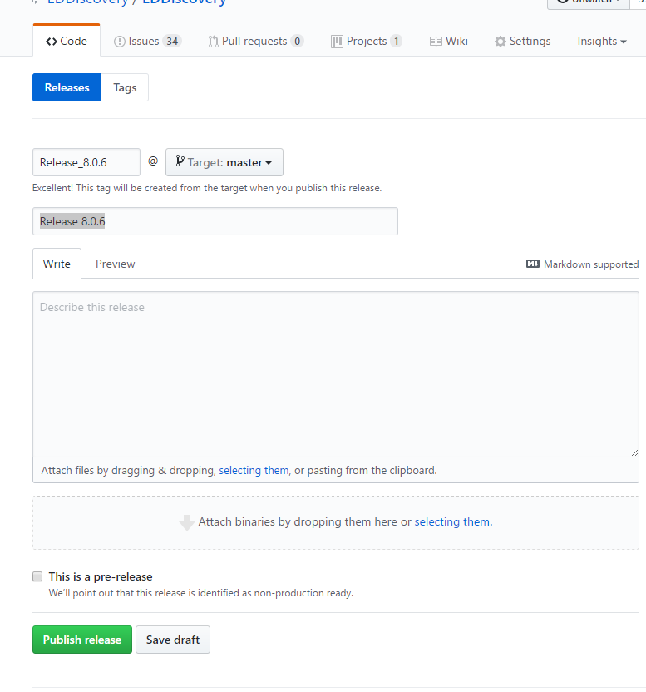

1. Drag and drop the EDDiscovery.exe release to the area under description.   
     
   It will then upload the exe file

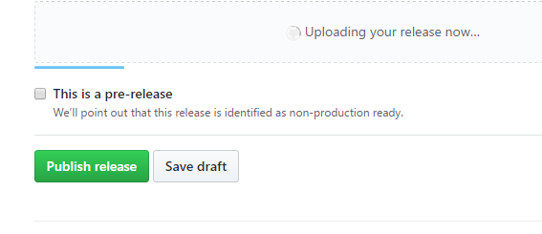

1. Go to EDDiscovery\EDDiscovery\bin\Release directory

Upload EDDiscovery.Portable.zip to the same area as above.

1. Publish the release. I mostly do it as a pre release first and then install it to test. And change pre.release flag after its tested. If it’s a beta / prerelease keep pre release flag on.  
   